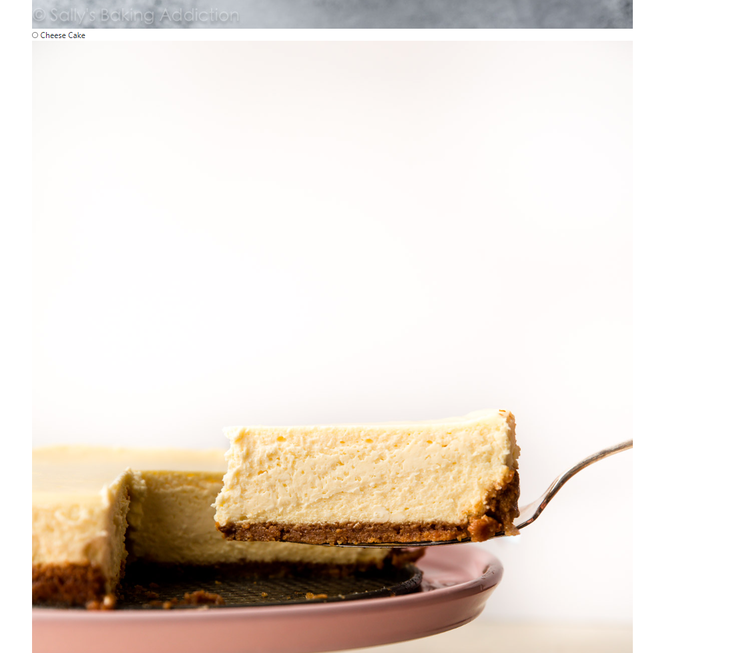

@page

@model Lesson12.Pages.BakeryModel

@{

}

<h1>Zeph Tan S10223377B Cakery</h1>

<form method="post">

<p>

Name: <input type="text" asp-for="Name" />

Address: <input type="text" asp-for="Address" />

</p>

<table class="table">

<thead>

<tr><th>Cake</th><th>Price</th></tr>

</thead>

<tbody>

<tr><td>Strawberry</td><td>$35.00</td></tr>

<tr><td>Cheese</td><td>$38.00</td></tr>

<tr><td>Chocolate</td><td>$30.00</td></tr>

</tbody>

</table>

<p>

<input type="radio" asp-for="Cake" value="Strawberry Cake" checked="checked" />

Strawberry Cake <br />

<img src="https://sallysbakingaddiction.com/wp-content/uploads/2017/12/homemade-strawberry-cake-4.jpg" alt="Strawberry" /><br />

<input type="radio" asp-for="Cake" value="Cheese Cake" />

Cheese Cake <br />

<img src="https://sallysbakingaddiction.com/wp-content/uploads/2018/05/creamy-classic-cheesecake-recipe.jpg" alt="Cheese" /><br />

<input type="radio" asp-for="Cake" value="Chocolate Cake" />

Chocolate Cake <br />

<img src="https://sallysbakingaddiction.com/wp-content/uploads/2013/04/triple-chocolate-cake-4.jpg" alt="Chocolate" /><br />

</p>

<p>

<input type="checkbox" asp-for="AddIce" />

Ice Pack <br />

<input type="checkbox" asp-for="AddCandle" />

Candles <br />

</p>

<p>

Delivery datetime: <input type="datetime-local" asp‐for="DeliveryDate" />

</p>

<p>

<input type="submit" value="OK" />

</p>

<p>

Customer Information: @Model.CustomerInfo

</p>

<p>

Order Information: @Model.OrderInfo

</p>

<p>

Total Cost: @Model.TotalCost.ToString("0.00")

</p>

</form>

using System;

using System.Collections.Generic;

using System.Linq;

using System.Threading.Tasks;

using Microsoft.AspNetCore.Mvc;

using Microsoft.AspNetCore.Mvc.RazorPages;

namespace Lesson12.Pages

{

public class BakeryModel : PageModel

{

[BindProperty]

public string Name { get; set; }

[BindProperty]

public string Address { get; set; }

[BindProperty]

public string Cake { get; set; }

[BindProperty]

public bool Ice { get; set; }

[BindProperty]

public bool Candles { get; set; }

[BindProperty]

public bool AddIce { get; set; }

[BindProperty]

public bool AddCandle { get; set; }

[BindProperty]

public DateTime DeliveryDate { get; set; } = System.DateTime.Now;

public string CustomerInfo { get; set; }

public string OrderInfo { get; set; }

public float TotalCost { get; set; }

public void OnPost()

{

CustomerInfo = Name + " " + Address + " " + DeliveryDate.ToString(); ;

OrderInfo = Cake;

if(Cake == "Strawberry Cake")

{

TotalCost = 35.00f;

}

if (Cake == "Cheese Cake")

{

TotalCost = 38.00f;

}

if (Cake == "Chocolate Cake")

{

TotalCost = 30.00f;

}

if (AddIce == true)

{

OrderInfo += ", Ice Pack Included";

TotalCost += 0.50f;

}

if (AddCandle == true)

{

OrderInfo += ", Birthday Candles Included";

TotalCost += 1.00f;

}

}

}

}